A **matrix diagonal** is a diagonal line of cells starting from some cell in either the topmost row or leftmost column and going in the bottom-right direction until reaching the matrix's end. For example, the **matrix diagonal** starting from mat[2][0], where mat is a 6 x 3 matrix, includes cells mat[2][0], mat[3][1], and mat[4][2].

Given an m x n matrix mat of integers, sort each **matrix diagonal** in ascending order and return *the resulting matrix*.

**Example 1:**

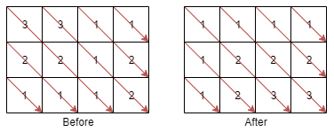

**Input:** mat = [[3,3,1,1],[2,2,1,2],[1,1,1,2]]

**Output:** [[1,1,1,1],[1,2,2,2],[1,2,3,3]]

**Example 2:**

**Input:** mat = [[11,25,66,1,69,7],[23,55,17,45,15,52],[75,31,36,44,58,8],[22,27,33,25,68,4],[84,28,14,11,5,50]]

**Output:** [[5,17,4,1,52,7],[11,11,25,45,8,69],[14,23,25,44,58,15],[22,27,31,36,50,66],[84,28,75,33,55,68]]

**Constraints:**

* m == mat.length
* n == mat[i].length
* 1 <= m, n <= 100
* 1 <= mat[i][j] <= 100